What should I do? (Thinking about Mission)
Revd Dr Hannah Steele
Part 1: What is Mission?
The word mission occurs sparingly in the English translation of the Bible. It stems from the Latin verb mitto (with missio being the noun form) and simply means ‘to send’.
What has mission got to do with theology?
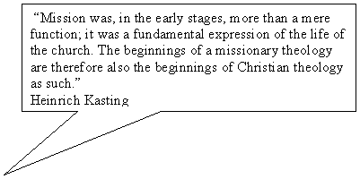
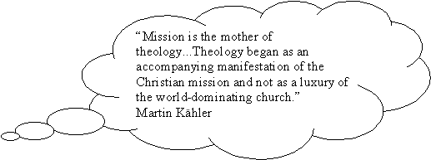
‘The New Testament writers were not scholars who had the leisure to research the evidence before they put pen to paper. Rather, they wrote in the context of an “emergency situation”, of a church which, because of its missionary encounter with the world, was forced to theologize.’ (Bosch, Transforming Mission p.16)

Foundations for Missional Theology
- The Mission of God. (Missio Dei)
So mission has a Trinitarian basis and is theocentric rather than anthropocentric.
It is not the church that has a mission of salvation to fulfil to the world; it is the mission of the Son and the Spirit through the Father that includes the church, creating a church as it goes on its way […] The church participates in Christ’s messianic mission and in the creative mission of the Spirit.
(Moltmann, The Church in the Power of the Spirit: a contribution to Messianic Ecclesiology (London: SCM Press, 1977) p.64)

Genesis ch12:1-3: and all peoples on earth will be blessed through you.

Luke: 24: 27 This is what is written. The Messiah will suffer and rise from the dead on the third day, and repentance for the forgiveness of sins will be preached in his name to all nations’.

“A church effectively engaged in mission will see that participating in the missio dei will involve shifting emphasis from a focus on the life of the local church...to a concern for the world in its need, joys and struggles”. (Robert Warren)

- Mission and Jesus

Missio = Sending

3 Sendings in the New Testament

- The sending of the Son (Luke 9:48, John 3:16-17)

- The sending of the Spirit (John 14:26).

- The sending of the church (John 17:18).

‘Peace be with you. As the Father has sent me, so I send you’. When he had said this, he breathed on them and said to them, ‘Receive the Holy Spirit’. (John 20:20-21)

Jesus’ Mission Manifesto
Luke 4: 16-21
Jubilee the Year of the Lord’s Favour
Who receives God’s blessing?

Jesus’ Mission Mandate.
Matthew 28: 19-20

c. Mission and the Holy Spirit

Acts 2: Pentecost – enabling the Gospel proclamation in a myriad of languages.

Acts 4: 31 Empowering the disciples to preach the Gospel

Acts 10 – Peter prompted to go to Gentle Cornelius

We have imagined ourselves to be, and we have acted so as to become indispensible. In everything we have taught our converts to turn to us, to accept our guidance. We have asked nothing from them but obedience. We have educated our converts to put us in the place of Christ. We believe that it is the Holy Spirit of Christ which inspires and guides us; we cannot believe that the same Spirit will inspire and guide them.
(Roland Allen, Missionary methods: St Paul’s or ours? p.145)

Part 2: What Does Mission look like?

3rd Lausanne Congress on Global evangelization in Cape Town in 2010:
We are committed to world mission, because it is central to our understanding of God, the Bible, the Church, Human history and the ultimate future. The whole Bible reveals the mission of God to bring all things in heaven and earth into unity under Christ, reconciling them through the blood of his cross. In fulfilling his mission, God will transform the creation broken by sin and evil into the new creation in which there is no more sin or curse.

The Five Marks of Mission:
- To proclaim the Good News of the Kingdom
- To teach, baptise and nurture new believers
- To respond to human need by loving service
- To transform unjust structures of society, to challenge violence of every kind and pursue peace and reconciliation
- To strive to safeguard the integrity of creation, and sustain and renew the life of the earth
(1984 Anglican Consultative Council )
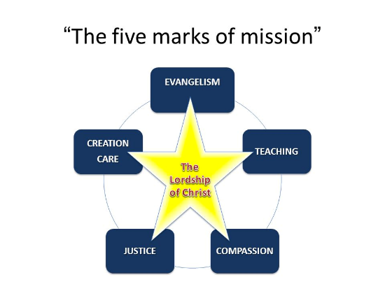

Part 3: What should I do?
- Live Humbly

Evangelism should grow out of love for God and neighbor. Hence, too, Paul’s succinct description of the motivation for evangelism: “For Christ’s love compels us” (2 Cor 5:14). But evangelism must also be done in such a way that it conforms to the principles of love. It should not destroy the other person. It should cherish the other person as someone loved by God. It should respect the other person, even though there may be disagreement with the beliefs of the other person. It should also care for the whole person. (Theissen, The Scandal of Evangelism p.34)

- Live Curiously

We should make good people wish that Christianity were true and then show them that it is (Pascale)

- Live Authentically

I have come to feel that the primary reality of which we have to take account in seeking for a Christian impact on public life is the Christian congregation. How is it possible that the gospel should be credible, that people should come to believe that the power which has the last word in human affairs is represented by a man hanging on a cross? I am suggesting that the only answer, the only hermeneutic of the gospel, is a congregation of men and women who believe it and live by it. (Lesslie Newbigin, The Gospel in a Pluralist Society (Grand Rapids, MI: Wm. B. Eerdmans, 1989), p. 227.)

We always give thanks to God for all of you and mention you in our prayers, constantly remembering before our God and Father your work of faith and labour of love and steadfastness of hope in our Lord Jesus Christ.
(1 Thessalonians 1.2-3)

a kind of participation in God that means participation in the world in a radically new way. Thus faith, love and hope have to do with the distinctive form of Christian participation in the world; they are not merely centripetal activities but centrifugal ones. In other words they have to do with witness, with mission. (Michael J. Gorman, Becoming the Gospel: Paul, participation and mission (Grand Rapids, MI: Wm. B. Eerdmans, 2015 p.65)

